
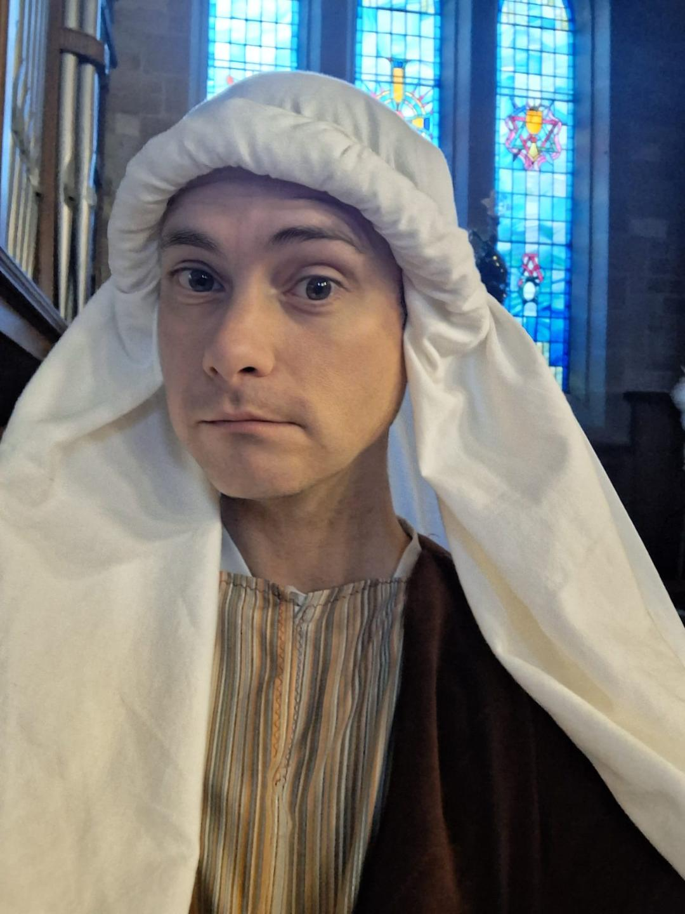

(A Scottish Charity Reg No SC015287)
“Joseph” 2025
Thank you

Update from Lenzie Union 17th January 2026

Dear Friends

Happy New Year for 2026!
We recently celebrated Epiphany on January 6th when the Christian church traditionally commemorates the Magi’s visit to Jesus. The season of epiphany starts on January 6th and typically lasts until the day before Ash Wednesday or the start of Lent. Before we take the Christmas decorations down and put them away we sometimes have a discussion about when this should be done – January 5th or 6th – and there are occasionally different opinions on when that task should be completed. Epiphany might not receive much attention apart from that.

The importance of the journey of the magi can sometimes be overlooked, viewed as an appendage to the Christmas story when the angel appeared and the shepherds rushed to find the baby Jesus in Bethlehem. Indeed when they later found the child in the stable the Magi experienced an epiphany they had travelled in hope of experiencing, but had not dared to expect. Their hope in following that star belied what their years of study had taught them. When the star led them to Jesus they experienced an epiphany – a revelation, a sudden realisation, a flash of understanding which made their journey completely worthwhile and indeed one of the most important moments in history.

Church Family News
Mrs Catherine Oliver sadly died at the end of November 2025. As we give thanks for Cath we remember her friends and family, and all who miss her most.
New Members
We are thankful to have recently welcomed 5 new members into the fellowship of our church family.
In October we welcomed Nicola McKeand, who transferred her membership.
On Sunday 30th November we welcomed Emily Fraser, Magnus Logan, Annabel Stewart and Calum Stewart as they professed their faith publicly and became members of the church.
We give thanks to God for each one and ask for His blessing on each one of them.

The
Bethlehem
Experience
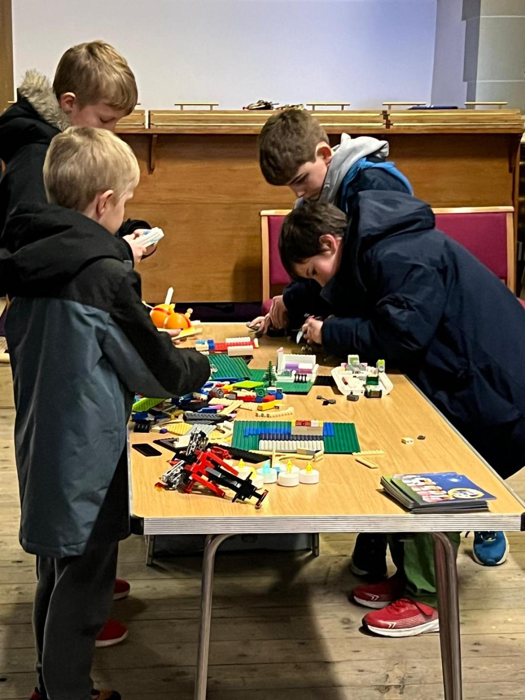
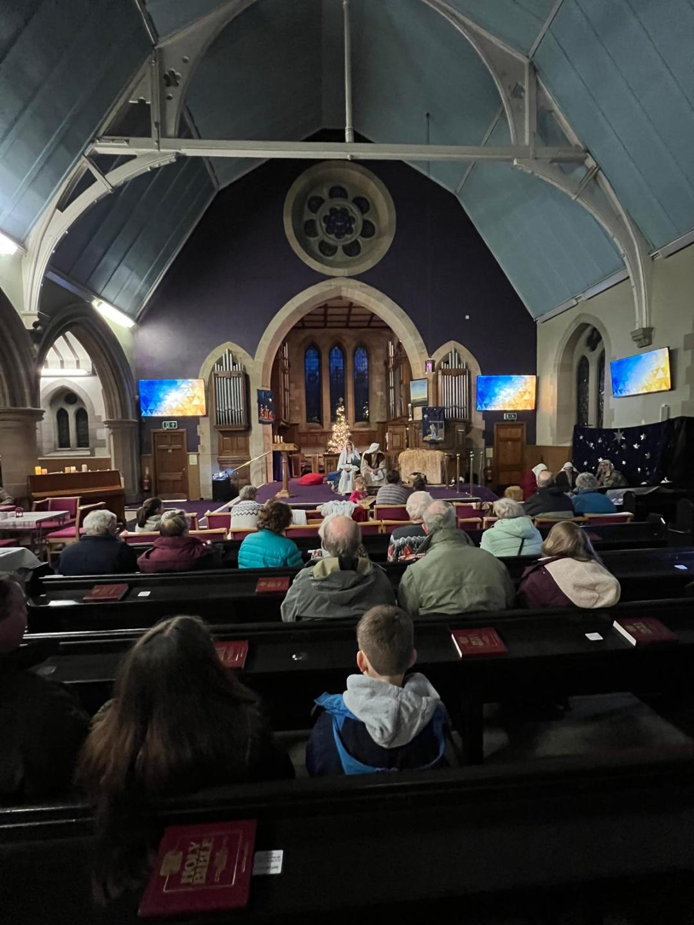
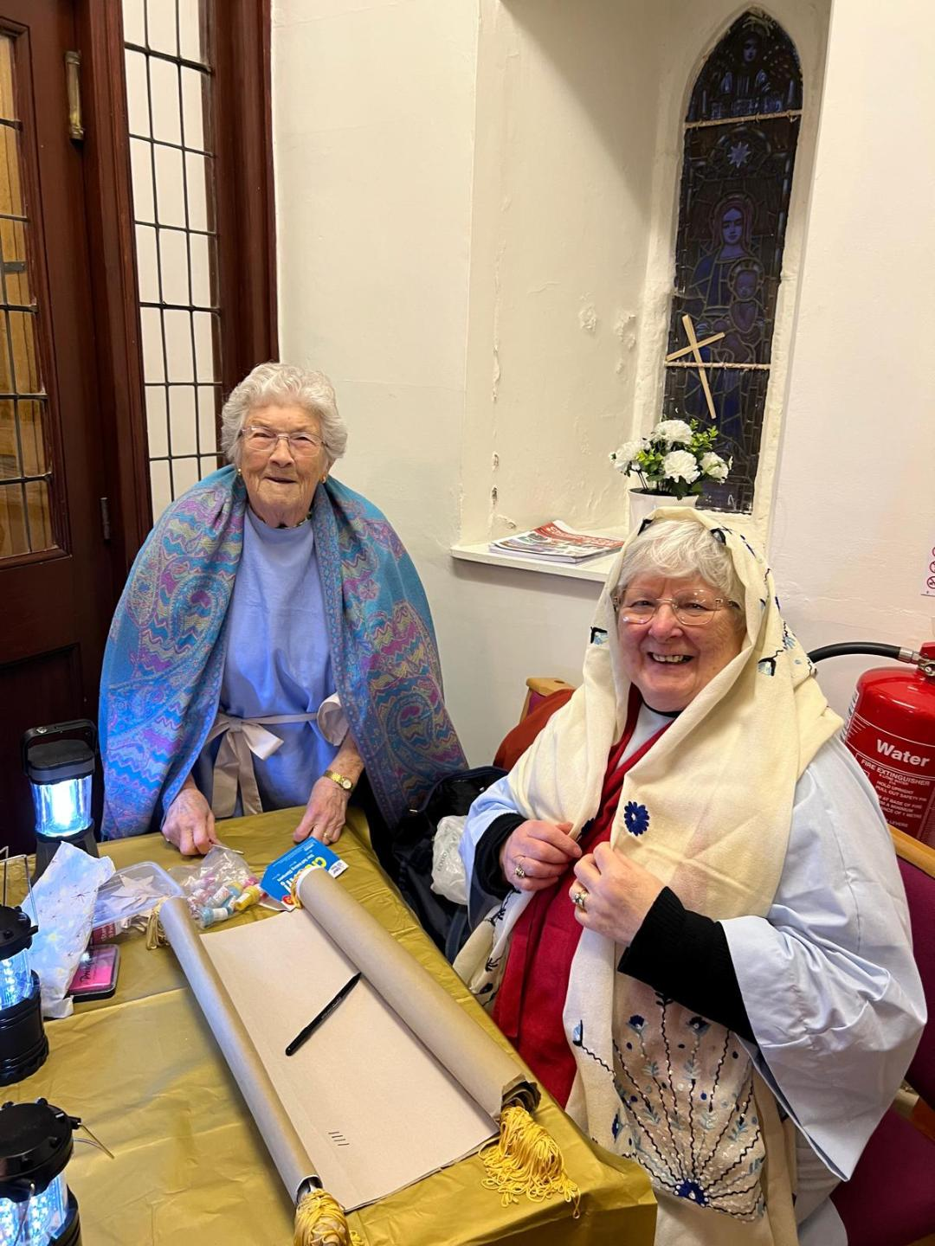

Worship for January and February
Sunday Worship
Sunday 18th January: Rev Leslie Grieve
Sunday 25th January: Rev Adah Younger
Sunday 1st February: Cluster service in Lenzie Old Parish at 11.00aam
Sunday 8th February: Rev Adah Younger
Sunday 15th February: Rev Leslie Grieve
Sunday 22nd February: Mission Sunday led by Rev Donald Macleod.
Sunday 1st March: Rev Leslie Grieve. There will be a fellowship lunch after the service.
As we move towards uniting our congregations we will share joint services with Lenzie Old on the 3rd Sunday of every month, beginning in March 2026.

Basis of Union Update
Over the last couple of months, the delegation panel appointed by Presbytery at the request of Lenzie Union and Lenzie Old have made visits to both churches and held a meeting with both individual congregations. Their recommendation on the use of the buildings for the united church will be brought to a joint meeting of the congregations on Thursday 12th February 2026. This meeting will be held in in St Cyprian’s Episcopal Church, Beech Road, Lenzie, 7.00pm for 7.30pm. A letter giving information on this will be issued separately.
The joint steering group met in December to plan future meetings. They will meet again on the afternoon of the 12th February, as arranged. Once the decision on the buildings is known the group’s discussions can focus on other aspects of the Basis of Union, which include finance, governance and what our church will be called. Thank you for your suggestions on a name for the united church - these will all be considered in our planning.
Our facilitator will meet with us to give guidance going forward, and we will keep you informed of progress.

Lenzie Union Parish Church Guild Coffee Morning in the New Hall
Saturday 7th March 2026 - 10.00 to 12.00
The proceeds from our Coffee Morning will go to this year’s Guild Projects. All are welcome to join us at this popular coffee morning.

The Christmas Experience
What an experience! Set back ….after set back after setback !
Among the many setbacks were
- The yellow weather warning preventing one school from sending their pupils.
Although disappointing for us and for the pupils, this allowed us to have more time to practise!
- Illness and injury 4 of the main characters were unwell - one with painful dental problems …so no Mary, one with covid, …so no narrator, one with a terrible tummy upset, …so no Gabriel and one with an injured knee,… so no Joseph!
I’m amazed that by 11pm that evening I had found a Joseph, someone who was willing to travel all the way from Broxburn and arrive by 9am! He was a Godsend! And he played the part with such enthusiasm, encouraging others to do the same! He even brought his bagpipes and surprised everyone by playing Christmas carols at the end of some of the performances!
I am so grateful to all those who stepped in to fill the other vacancies too -Mary, Gabriel ,the Narrator and Anna They all rose to the occasion and saved the day!
Everything worked out really well in the end! So much better than we could ever have expected! Praise God!
Altogether people from 5 different churches, including our own, were involved. I’m delighted that some Lenzie Union members joined the faithful participants in the cast for the first time…..Every one of them a star!
WELL DONE EVERYONE for helping to share the story of the very first Christmas in such a refreshing way!…..to over 80 pupils and their teachers, and around 100 members of the public! WHAT A JOY!..... WHAT A TRIUMPH! ..... WHAT AN EXPERIENCE!

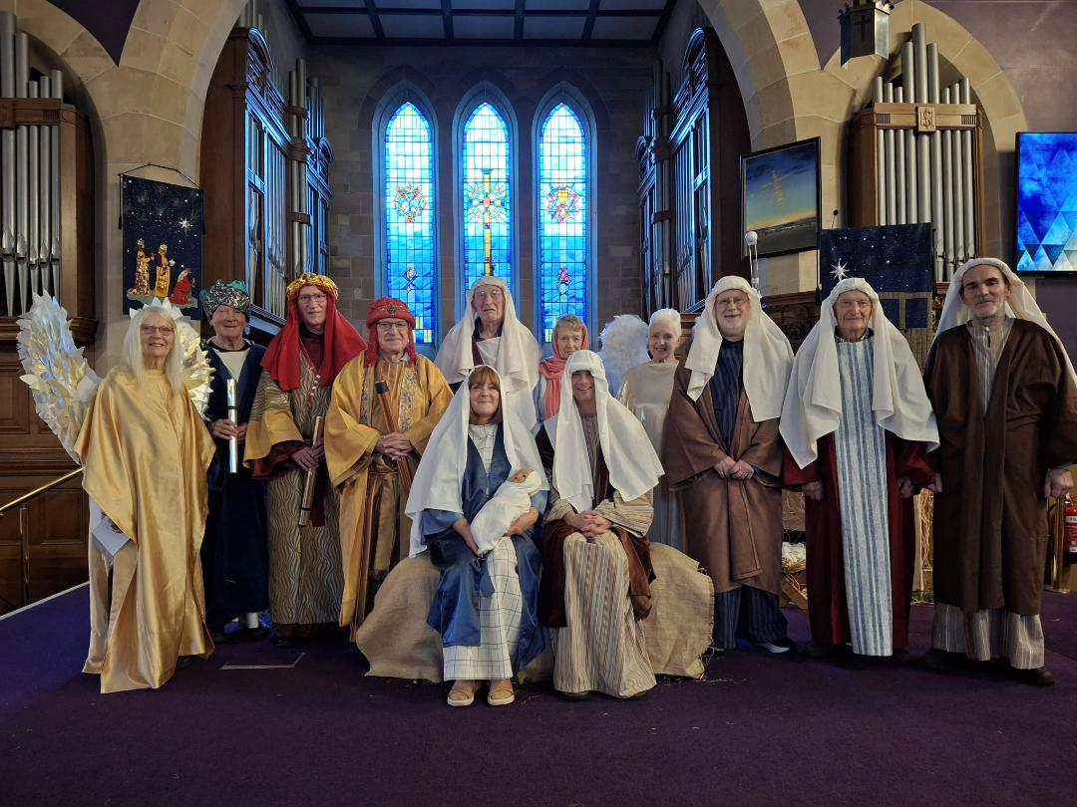

ANNUAL GIVINGS R£VI£W – URG£NT
We thank all members for your faithful and generous giving throughout the last year, helping Lenzie Union continue its community-wide involvement in spreading the Gospel to all ages. Our draft Annual Budget for 2026 assumes that LUPC will continue to operate normally for the full 12 months but that comes at a cost that we are currently not in a position to cover fully.

In short, for largely demographic reasons our income remains fairly static, meaning that annual cost inflation is not being met. Further, your generosity in recent years is reflected in the calculation of our annual payment to Central Church (Giving to Grow contribution), as a result of which we are facing a 7% increase (approx. £7,000) in 2026. We also have the continuing, generally upwards, trend in our energy costs and have our various employees to support annually, within youth and pastoral work and in the running of the church.

Our Budget is currently showing a sizeable deficit for 2026 which cannot be sustained without either a significant uplift in offerings income and/or an equally significant reduction in our costs.

This challenge is not new as you will know. Recent new members who have not done so and are in a position to consider making regular givings are asked to contact the Treasurer or your Elder. For everyone else, please give prayerful consideration to your recent givings and whether they reflect the changes the church has been facing recently – you can make a difference to what we do this year. Inevitably the Kirk Session will be discussing the painful options of cutting back on our current operating expenditure but will be helped if any uplift in regular givings can be detected at an early date.

The Presbytery Mission Plan will come to a conclusion on our future shortly. Whatever decision is reached, we at Lenzie Union have a mission to perform and let us pray that support will be forthcoming in all its forms over the coming year. Blessings to you all for this new year.
Ken MacLeod, Treasurer

Do you like playing Chess? Deafblind Scotland is searching for a volunteer who enjoys playing chess and could potentially play chess with a deafblind man on some Monday mornings perhaps once a month. The game of chess would take place in Deafblind Scotland’s building so if you live in Lenzie or Kirkintilloch there is little travel involved. John is a profoundly deaf sign language user and has a guide/communicator with him for the 1.5 hours long chess session. Playing chess is one of John’s favourite pastimes and finding a person who could commit some time to playing with him would bring great pleasure to him. Please speak to Drena O’Malley for more information in the first instance. 07774192659. Thank you

You are warmly invited to…..

Ladies and Gentlemen

The LUPC GUILD would like to invite everyone

to their last afternoon meeting
on Monday 2nd February 2026 at 2.00pm
when we have the fabulous Semitones
(a small group from the Westerton Male Voice Choir)
coming along to entertain us
Please Join Us in the New Hall

'Thank you for inviting Karen, David and I to your anniversary service recently. It really was heart warming to enjoy such a positive welcome back to Lenzie Union, to meet again with so many friends and to enjoy the fellowship of the service and lunch. For me it felt like a foretaste of the eternal joy we all hope for in Christ. I pray God will continue to bless your work in Lenzie.

May the grace of the Lord Jesus Christ, the love of God and the fellowship of the Holy Spirit be with you all.

Robin, Karen and David Orrock'

The LUPC Guild Meeting
on Monday,19th January 2026
at 2.00pm in the New Hall
has Cathey and Christina telling us all about
one of our Guild Projects for this year
Bear Necessities
and about their work in a village
called Orizari, Bulgaria



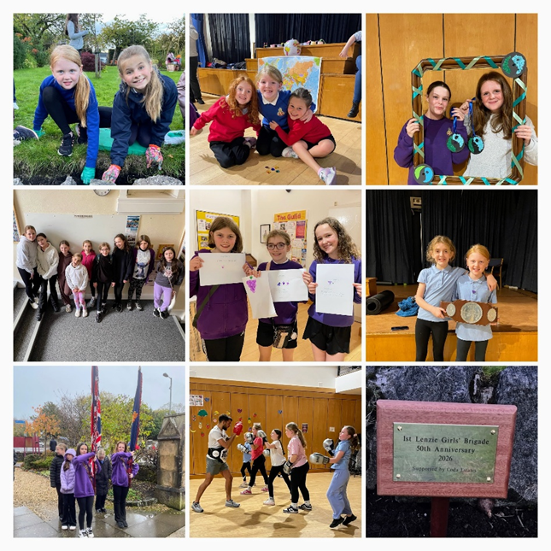
1st Lenzie Girls’ Brigade had great fun in the lead-up to Christmas with various events. We had Baking at Home with Rhona when we made muffins in a variety of flavours: white chocolate and raspberry, blueberry, lemon and other combinations. The girls were really pleased with their baking and their families appreciated it too! The Nethy Bridge trip girls went tubing at Bearsden Ski Centre and had a thrilling time there, with a few ‘spills’ too. The Brigaders had a night out at Craft Daft on a Raft making Christmas ornaments and we made our own Christmas decorations in the hall too. There was also a Christmas movie night watching ‘Arthur Christmas’ in the hall with popcorn and snacks and, finally, we all enjoyed the Christmas party with a special visitor! Thanks to Coda Estates for funding the party again this year. It’s been a busy festive period!

RESPAWN
The Ultimate Gaming Night
Launch Event – Saturday 21st February, 7–9pm for young people in Primary 7 - S1 -S6
Get ready to level up your Saturday night.
Respawn is the brand-new gaming event where competition, music, food, and good vibes collide.
⭐ What’s Going Down
- E-Sports style tournament Nintendo Switch • Xbox • VR - Live DJ mixing decks bringing the hype
- Free food + drinks - Gaming voucher prize for the champion
- A short, chilled faith reflection that actually makes sense - Your gateway into our 6-week Thursday night gaming programme
And After Launch Night…Respawn continues every Thursday, 7–9pm, with:
- Multiplayer gaming - Food - Space to hang out - New challenges each week
If you love gaming, good company, and a place to belong, Respawn is your next checkpoint.
Kim Halliday-Robertson Children & Youth Worker Lenzie Union Parish Church 65 Kirkintilloch Rd Lenzie

Lenzie Jog 2nd January 2026 welcomed one of the biggest fields ever seen at the Jog with over 600 people taking part in three different distances – 2.2k, 4.3k, and 8.6k. Over 250 people mainly families and

children took part in the 2.2k. More than 40 marshals fro Lenzie Community Council and Kirkintilloch Olympians - marshalled the course with a view to keeping people safe. It was a lovely day, cold but sunny but free from snow or ice – perfect!

Lenzie Loves Lego
7th February 10.30-11.30
7th March
28th March
25th April
23rd May
13th June
Old Hall or Session House
Messy Church Dates
7th February 4.00 – 5.00
7th March
28th March
25th April
23rd May
13th June

I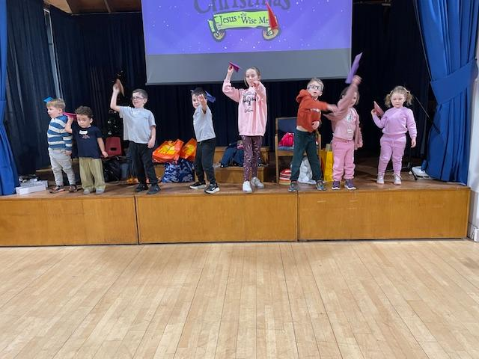n LUPC New Hall

If you have information, news, stories you would like to share please email omalleydom@yahoo.co.uk

Having made a paper aeroplane at Messy Church one has to check who’s aeroplane flew the furthest……..
‘Quiet Time’ In January the Kirk Session discussed the option of reintroducing a ‘Quiet Time’ in the sanctuary which had been suggested last year. The “Quiet Time” ran successfully for many years before the pandemic, initiated during the Gulf War to allow people space for quiet prayer. Laterally it was held successfully from 10.00 till 11.00 am on a Wednesday morning, allowing visitors to join the Meeting Place for coffee, and this could be an option again. However Volunteers are needed if we are to make this happen again. We invite your thoughts on whether you would like to see this happen, and if you would be willing to volunteer from time to time? You can speak to either your elder or to myself. Thank you, Fiona



